Between

Sarah Tucker and Ingenium Wines, LLC

This agreement (the ‘Agreement’) is made this _________ day of October 2016, by and between Sarah Tucker (Tucker) and Ingenium Wines, LLC (Ingenium).

WHEREAS, Ingenium is in the business of importing wine from outside the United States for sale to distributors throughout the United States;

WHEREAS, Tucker is a photographer;

WHEREAS, Ingenium desires to acquire original art from Tucker.

WHEREAS, the parties hereto wish to establish the terms and conditions of their agreement;

NOW THEREFORE, for good and valuable consideration, the sufficiency of which is hereby acknowledged, the parties agree as follows:

1. Artwork

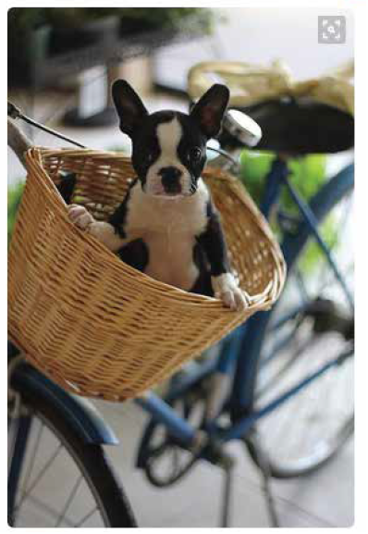

2. Usage and rights to artwork

Ingenium will receive ownership of the original artwork. Additionally, Ingenium will retain the exclusive rights to the use of the art for corporate purposes including, but not limited to, wine boxes, advertisements, promotional material, web sites, email, and merchandise.

3. Compensation

$400

4. Exclusivity

Tucker herein grants to Ingenium the exclusive use of the image purchased for this purpose by Ingenium and will not duplicate the exact image for any other purpose.

5. Warranties.

Each Party warrants that (a) no contractual obligations exist which would prevent it from entering into this Agreement; and (b) it has the requisite authority to execute, deliver and perform this Agreement.

6. General.

1. Governing Law. The validity, interpretation and performance of the Agreement shall be governed by the substantive laws of the State of Alabama, without regard to conflict of law principles.
2. Entire Agreement; Amendment. This Agreement constitutes the complete and exclusive statement of the agreement between the Parties on the subject matter herein and supersedes all previous agreements, arrangement and undertakings with respect thereto, whether written or oral. This Agreement may be modified only mutual consent of both Parties provided that, before any modification shall be operative or valid, it be reduced to writing and signed by both Parties.
3. Waiver of Provision. The failure of either Party to insist on strict performance of any of the provisions hereunder shall not be construed as a waiver of the whole agreement of any part thereof.
4. Severability. If any provision of this Agreement is held to be unenforceable or invalid, the other provisions shall continue in full force and effect.
5. Notice. Any notice required or permitted to be given hereunder shall be given by: (a) Registered or Certified Mail, Return Receipt Requested, postage prepaid; (b) by confirmed facsimile; or (c) by nationally recognized courier service, with confirmation of delivery, to the other Party at the address of their corporate headquarters or to such other address as a Party may designate in writing; or (d) by email with return receipt confirmation.

IN WITNESS WHEROF, the Parties have caused this Agreement to be executed by their authorized representatives.

Sarah Tucker Ingenium Wines, LLC

By: ________________________ By: _________________________

Sarah Tucker Bjoern Lanwer

President

Date: ______________________ Date: _______________________

Witness: ­­___________________ Witness: ­­____________________